Arts Queensland project plan completion guide

This guide is intended to assist applicants with completing their project plan
for Arts Queensland (AQ) funding programs through the online grant system SmartyGrants.

For general advice on grant writing support, download the Arts Acumen Funding application writing toolkit or contact Arts Queensland fund managers.

Remember to always Save Progress at top or bottom of the page.

Example: Completed timeline and activity plan
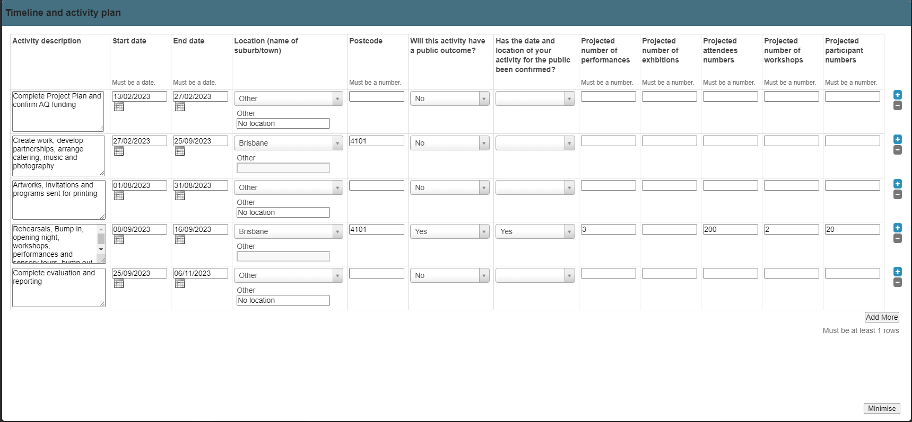

You can add new rows if you need to add more activity lines

You can minimise and maximise the plan to change the view.

Timeline and activity plan breakdown

Part 1 – Activity description, Start date and End date columns

Activity description - Enter all your key project activities on separate lines. You should enter activities such as performances, exhibitions or workshops that happen in different locations on separate lines.

Start and End date - Enter your key start and end dates noting you cannot start your project prior to the Activity Start date published in the Specific Fund Guidelines.

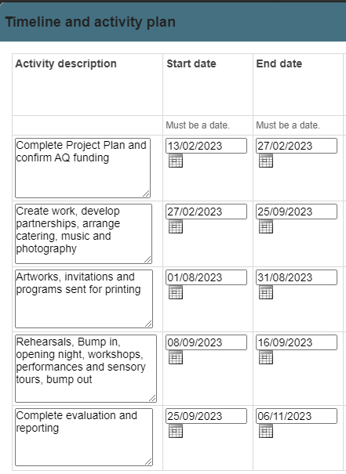

Part 2 – Location, Postcode and Public Outcomes columns

Location and postcode – You can choose a location from the drop down list or enter your location in the “other” box if it isn’t in the list.

If the location is a town without any suburbs, choose/give the town name and enter a postcode, otherwise give the suburb name and postcode. You can also select “Digital/Online only” for online public activities or “No location” for administration tasks.

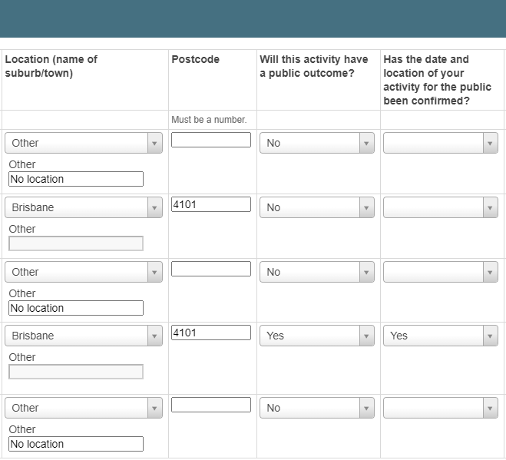

Public outcomes - Public outcomes mean the public can view the work, attend or participate in an activity. “The public” here means people other than the artists and arts workers involved in the project, so a workshop for a school would be a public outcome, even though the general public would not be able to attend.

Creative Development activities should answer “Yes” if they are doing a showing of an unfinished work that is open to the public.

If there are no public outcomes select ‘No’ for the column Will this activity have a public outcome?

Activities with public outcomes must have information in the final five columns.

Part 3 – Performances, Exhibitions, Workshops and Attendees and Participants

Projected number of performances/exhibitions
Performances and exhibitions can be delivered in person or digitally. Enter the number of performances or exhibitions taking place in the relevant location.

If you have a performance or an exhibition you must include information in the Attendee column.

Projected attendee numbers
Attendees are audiences for a live performance or event, or those viewing an artwork/exhibition in person, or those watching or listening to a one-off or live streamed online performance. Give an estimate of how many attendees you will have. Don’t count viewers of online performances that are available at any time.

Projected number of workshops
Count all workshops, classes, masterclasses or community activities here taking place in the relevant location. If you enter a figure in this column you must include information in the Participant column.

Projected of participant numbers
Participants are people who actively participate in your activities e.g. attend a class to make something, sing in a choir, engage in a training workshop. Don’t count artists and arts works, volunteers or your own staff.

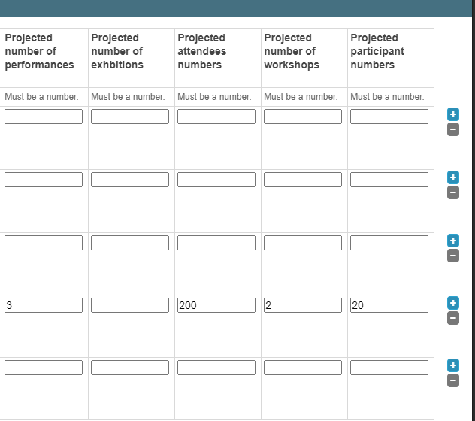
Do not include artists/artworkers/staff/volunteers

